Snow Bird

2018-12-06

Raymond Knorr, Ali Rizvi,

Priscilla Chua, Zain Abedin,

Li Pan, Sana Khan

Milestone 5 – Usability Evaluation Discussion & Product Demo/Delivery

The key feature in our content strategy is the creation of an individual private site for each sub faculty within engineering. There would also be a general site created for use by the faculty administrative staff. An individual user would only access their particular version of the private site. Throughout the development of our project, our main navigation had the four headings: Research Areas, Committees, and Course Material. By suggestion, we have also added a fifth main heading, Safety, to contain all of the info, forms, and documentation that specifically applies to safety.

Our usability questionnaire led to several key insights about our site that will be explained below. The pre-task questions that we had come up with did not cover any demographic information about the administrative staff being questioned, however we were still able to gather some knowledge about what type of users would be using the site. Firstly, virtually all of the users on the site will be non-technical, so the content management system must be intuitive to use for someone at any skill level. Therefore, we have to be very careful about adding any technical elements to the pages. The average users of the site, faculty-members, would probably have an easier time getting around a site that is specific to them. However, more regular users such as the administrative staff, would have no problem using a more complicated site after some learning time.

The questionnaire asked several task questions that were meant to test the actual functionality of the site. Throughout these tests, the participants were able to successfully navigate our working demo. Some of their thoughts on the navigation are:

New people that are looking for specific course material would likely prefer to search by the year, but more experienced users would find the course faster by searching through the professors. It is worth noting that the courses are already sorted by the sub faculty that the user is currently logged into. The participants also noted that the forms and documentation section is easy to navigate in its current state, but could become harder if it included all of the files that are currently on the faculty drive. The suggestion they made was the addition of the Safety main heading. This would provide an easy access point for all of the safety-related forms and would also provide some relief to the overcrowded documentation section. The last key point that they mentioned was that the Committee main heading is very important to users of the faculty private site.

The final set of questions making up the questionnaire were the post-task questions. These were meant to get a report of the user’s overall experience using our site. Overall, they thought that nothing was very confusing in our navigation structure, and they thought that the idea of splitting the site by sub-faculty could be very beneficial, although there would still be a need for a centralized site for the administrative staff.

The one revision that we decided to make to our content strategy was the aforementioned addition of the ‘Safety’ main heading.

Their are a few possible roadblocks in the real-world production of our site. The most prominent of which is that our entire proposal hinges on the fact that it is possible to separate the site based on sub-faculty. If it is, it would probably take a significant time investment to set it up, and likely even more to maintain it. However, once it is set up, it would provide a much more efficient workflow to the average user.

We were not able to test any of the actual security functionality of the private site. We do not know what kind of permissions the Cascade system gives to individual users. Our site fortunately would provide a base level of security based on the sub-faculty of the user. This would also mean that an administrative staff person would have a higher base security level than the average user.

A few images of our working Cascade Prototype:

Picture 1: The Cascade Homepage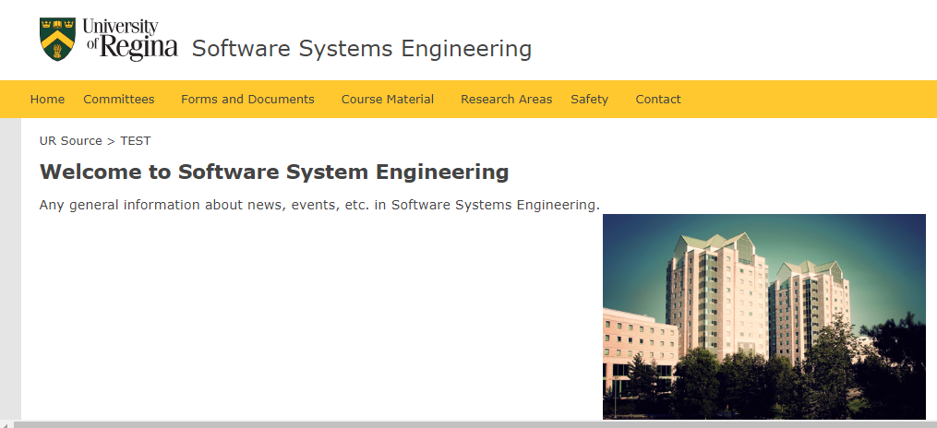

Picture 2: The Committees Section

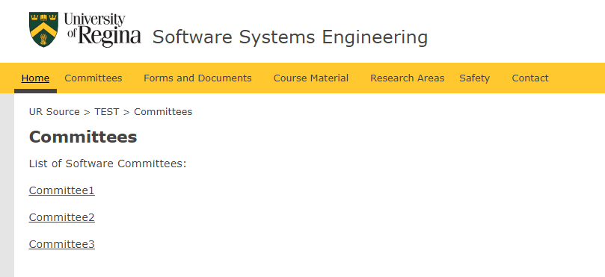

Picture 3: Course Material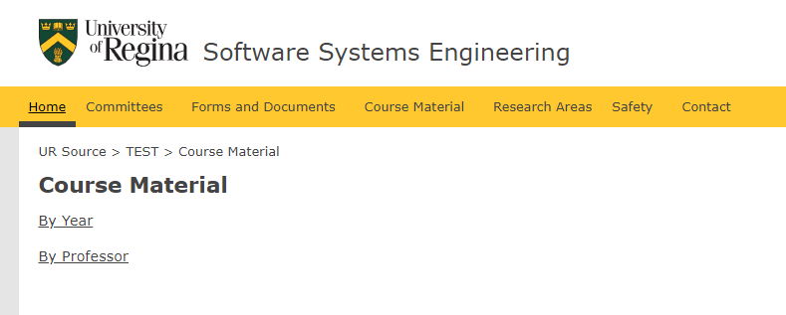

Picture4: Forms and Documents

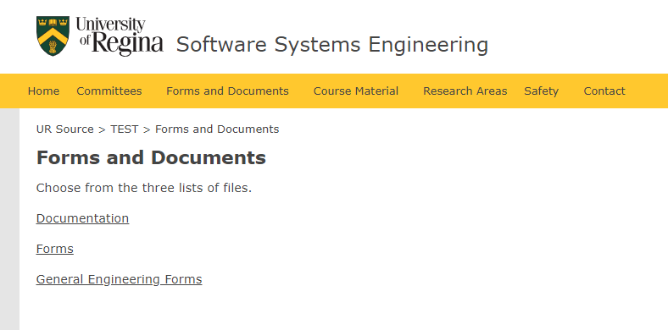

Picture 5: Research Areas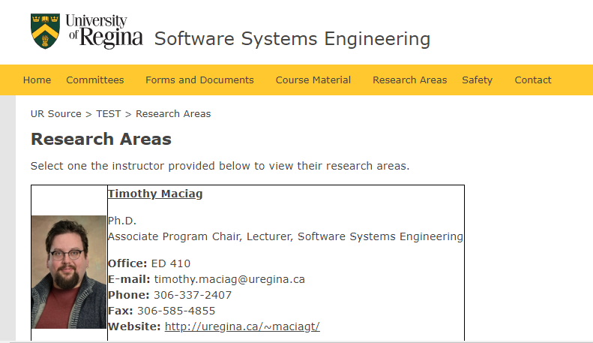

Picture 6: Safety Documentation Section

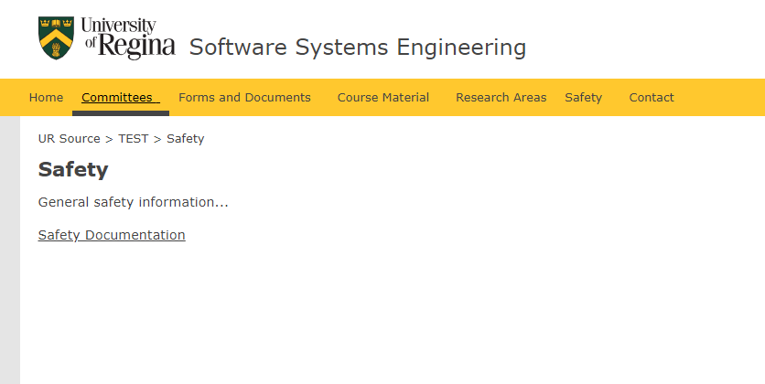

Picture 7: User Questionnaire First Page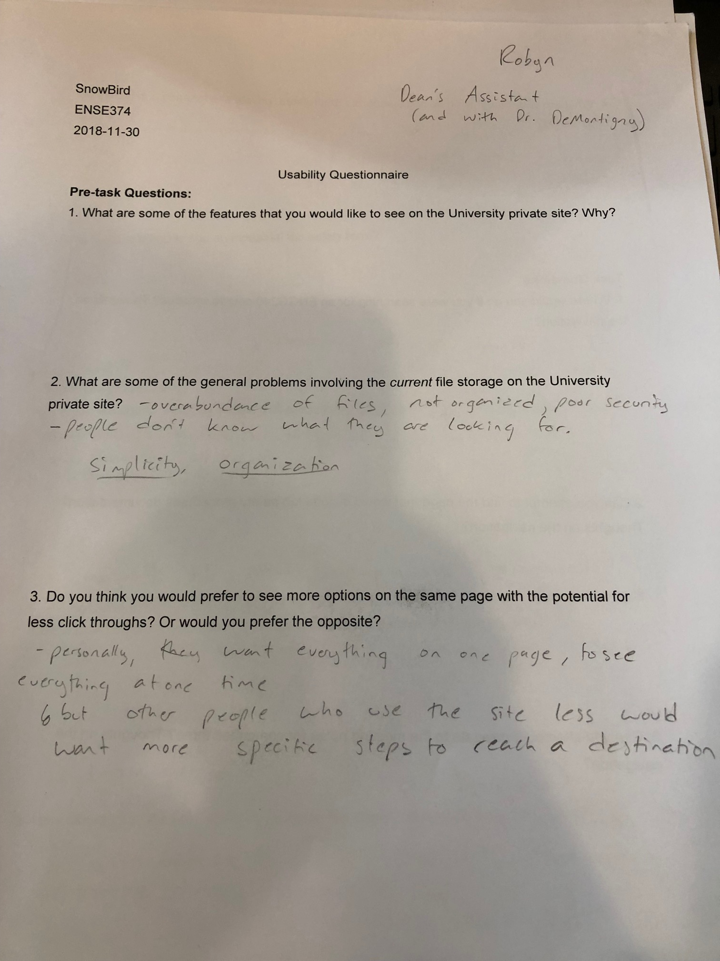

Picture 8: User Questionnaire Second Page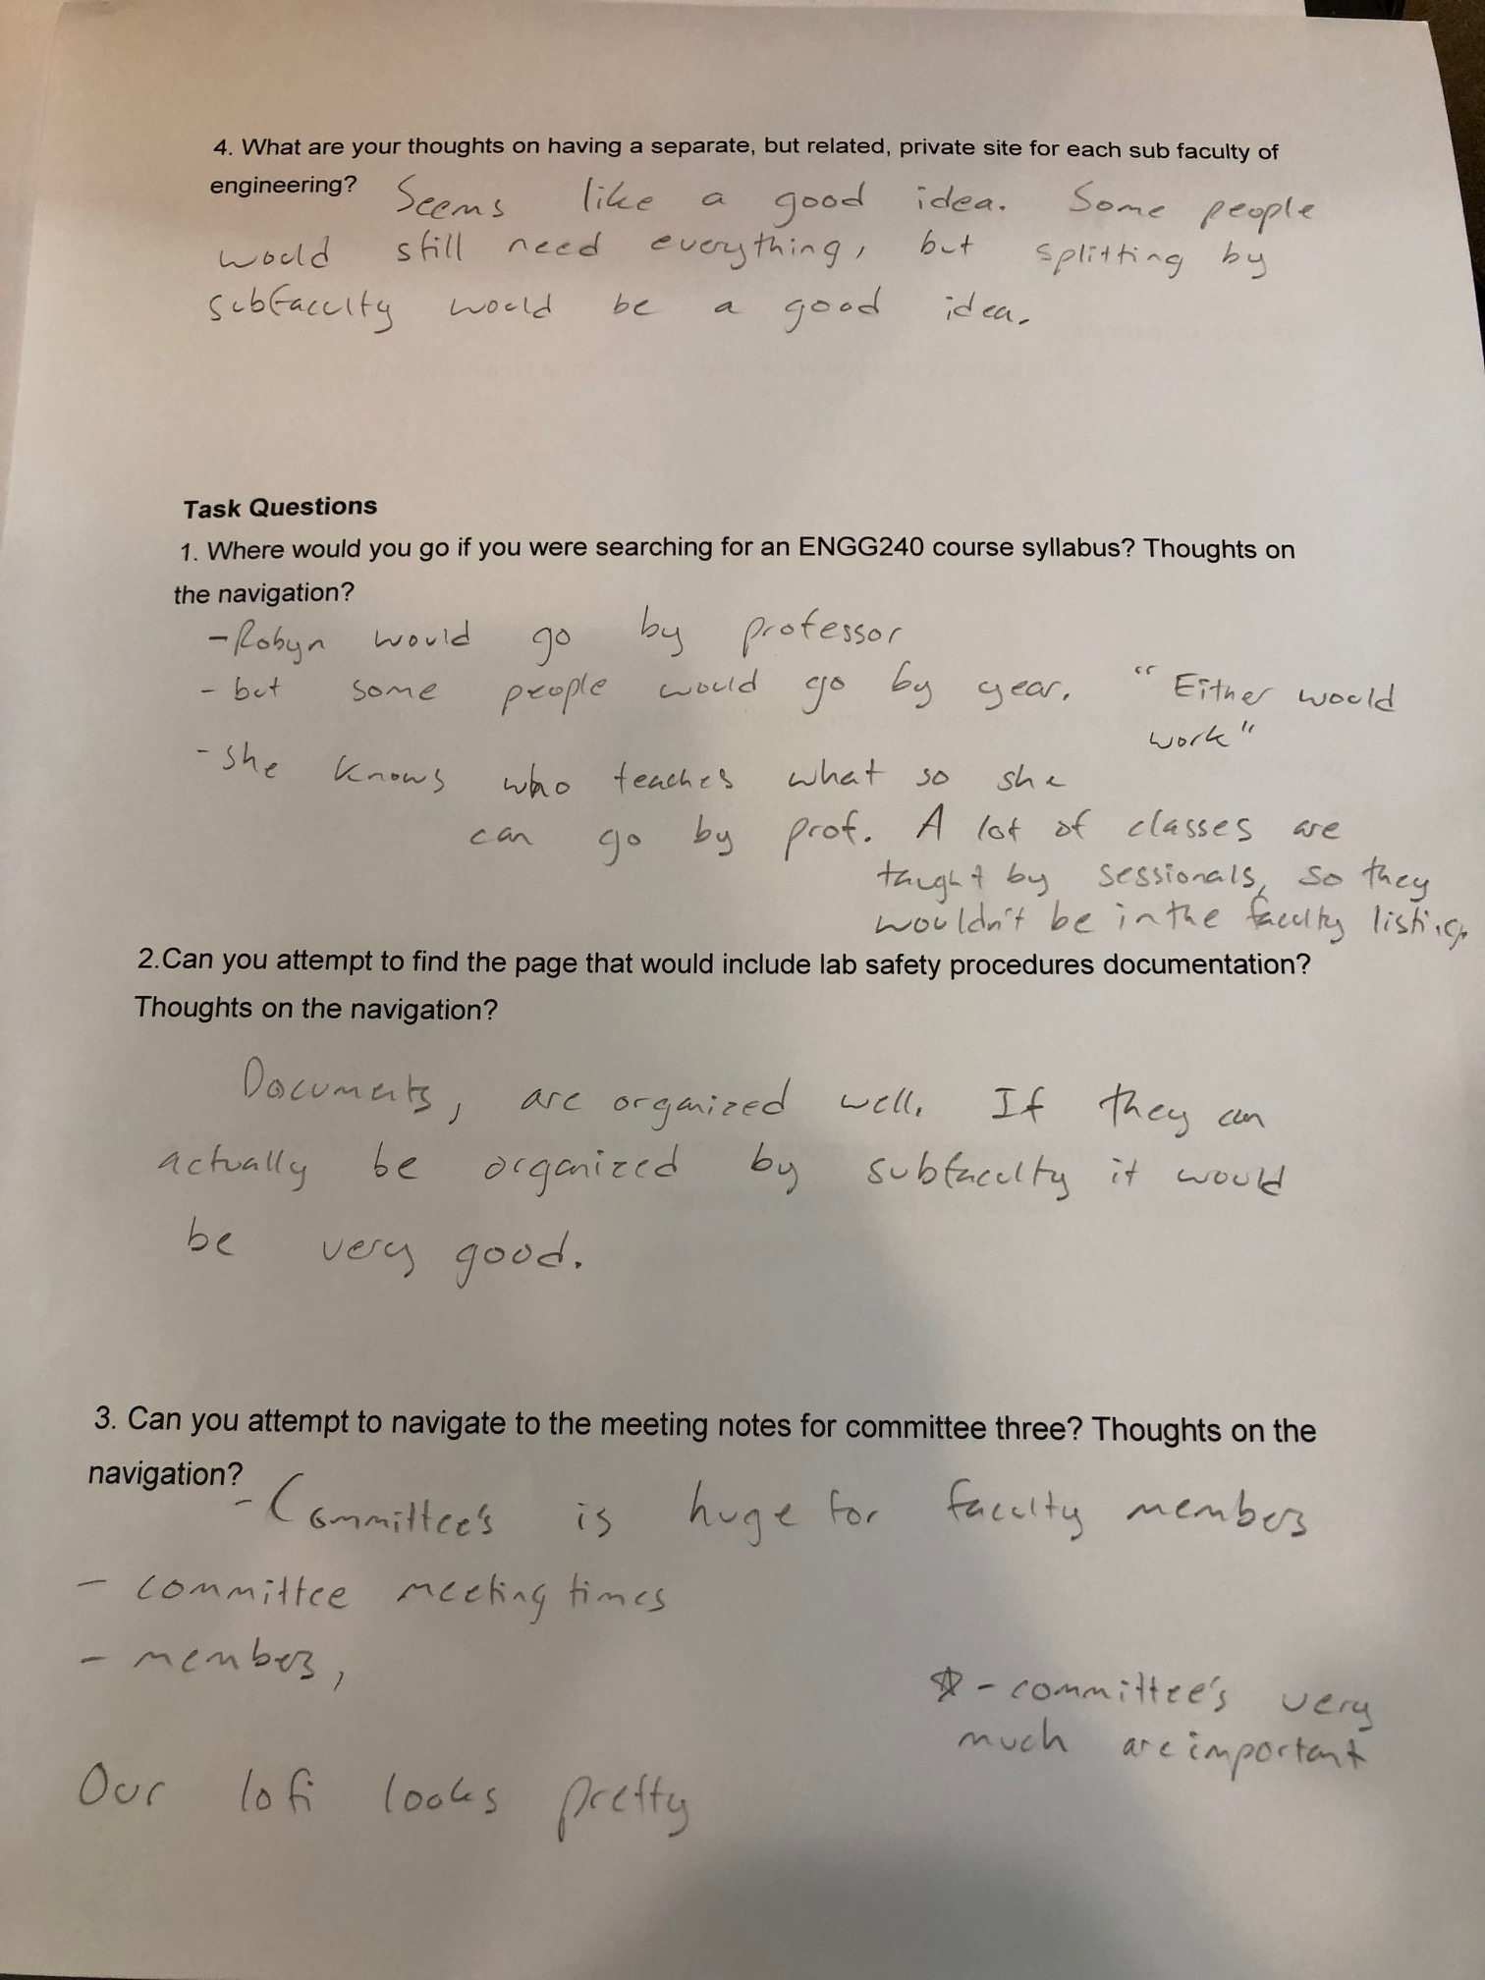

Picture 9: User Questionnaire Third Page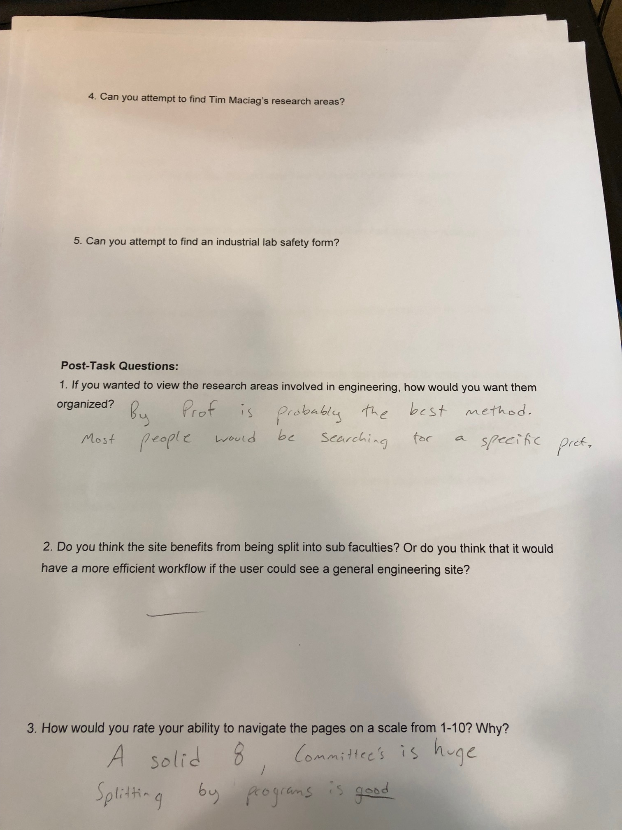

Picture 10: User Questionnaire Fourth Page